AI Assisted Coding
Assignment -6.3

Name: K Ashwitha
Ht No-2303A52216
Batch-45

Task 1: Classes (Student Class)
Scenario
You are developing a simple student information management module.
Task-1
• Use an AI tool (GitHub Copilot / Cursor AI / Gemini) to complete a Student class.
• The class should include attributes such as name, roll number, and branch.
• Add a method display_details() to print student information.
• Execute the code and verify the output.
• Analyze the code generated by the AI tool for correctness and clarity.
Expected Output #1
• A Python class with a constructor (__init__) and a display_details() method.
• Sample object creation and output displayed on the console.
• Brief analysis of AI-generated code.

Prompt:
#2216Generate a python code to develop a simple student information management module. The class should include attributes such as name, roll number, and branch.,Add a method display_details() to print student information

Code:
class Student:
def __init__(self, name, roll_number, branch):
self.name = name
self.roll_number = roll_number
self.branch = branch

def display_details(self):
print(f"Name: {self.name}")
print(f"Roll Number: {self.roll_number}")
print(f"Branch: {self.branch}")

# Example usage
if __name__ == "__main__":
student1 = Student("Alice", 101, "Computer Science")
student1.display_details()
print()
student2 = Student("Bob", 102, "Electronics")
student2.display_details()

Output:

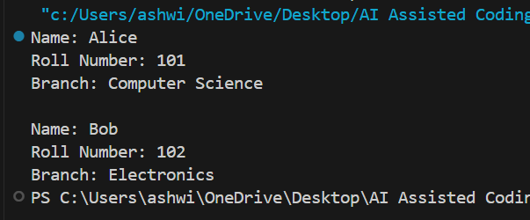

Justification:
Student Class Module
This module defines a Student class that represents a student with basic information.
Classes:
Student: A class to store and display student information.
The Student class includes:
- Attributes: name(str), roll_number(int), branch(str)
- Methods: display_details() - prints student information

Task 2: Loops (Multiples of a Number)
Scenario
You are writing a utility function to display multiples of a given number.
Task
• Prompt the AI tool to generate a function that prints the first 10 multiples of a given number
using a loop.
• Analyze the generated loop logic.
• Ask the AI to generate the same functionality using another controlled looping structure (e.g.,
while instead of for).
Expected Output #2
• Correct loop-based Python implementation.
• Output showing the first 10 multiples of a number.
• Comparison and analysis of different looping approaches

Prompt:
#2216Generate a function that prints the first 10 multiples of a given number
using a loop and also same functionality using another controlled looping structure (e.g.,while instead of for).

Code:

def print_multiples(n):
print(f"First 10 multiples of {n}:")
for i in range(1, 11):
print(n * i, end=" ")
print("\n")
# Alternative approaches comparison:
def print_multiples_while(n):
"""Using while loop"""
print(f"First 10 multiples of {n} (while loop):")
i = 1
while i <= 10:
print(n * i, end=" ")
i += 1
print("\n")
def print_multiples_list_comp(n):
"""Using list comprehension with unpacking"""
print(f"First 10 multiples of {n} (list comprehension):")
multiples = [n * i for i in range(1, 11)]
print(" ".join(map(str, multiples)), "\n")
# Example usage
if __name__ == "__main__":
print_multiples(5)
print_multiples_while(7)
print_multiples_list_comp(3)

Output:
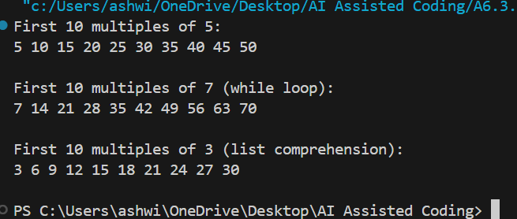

Justification:
Comparison and Analysis:
1. For Loop : Most Pythonic, readable, concise. Best for known iterations.
2. While Loop : Useful when iteration count is unknown. Requires manual counter management.
3. List Comprehension : Efficient for creating collections, readable, preferred for small datasets.

Task 3: Conditional Statements (Age Classification)
Scenario
You are building a basic classification system based on age.
Task
• Ask the AI tool to generate nested if-elif-else conditional statements to classify age groups
(e.g., child, teenager, adult, senior).
• Analyze the generated conditions and logic.
• Ask the AI to generate the same classification using alternative conditional structures (e.g.,
simplified conditions or dictionary-based logic).
Expected Output #3
• A Python function that classifies age into appropriate groups.
• Clear and correct conditional logic.
• Explanation of how the conditions work.

Prompt:

#2216Write a python code to generate nested if-elif-else conditional statements to classify age groups
(e.g., child, teenager, adult, senior)and also generate the same classification using alternative conditional structures (e.g.,simplified conditions or dictionary-based logic).

Code:

# Age Classification using nested if-elif-else
def classify_age_nested(age):
if age < 0:
return "Invalid age"
elif age < 13:
return "Child"
elif age < 20:
return "Teenager"
elif age < 60:
return "Adult"
else:
return "Senior"
# Alternative 1: Dictionary-based approach
def classify_age_dict(age):
"""
Classify age group using dictionary and conditional logic.
More maintainable for adding new categories.
"""
age_ranges = [
(0, 13, "Child"),
(13, 20, "Teenager"),
(20, 60, "Adult"),
(60, 150, "Senior")
]

for min_age, max_age, category in age_ranges:
if min_age <= age < max_age:
return category
return "Invalid age"
# Alternative 2: Using lambda and list
def classify_age_lambda(age):
"""
Classify age group using lambda functions.
Functional programming approach.
"""
classifiers = [
(lambda x: x < 13, "Child"),
(lambda x: x < 20, "Teenager"),
(lambda x: x < 60, "Adult"),
(lambda x: x < 150, "Senior")
]

for condition, category in classifiers:
if condition(age):
return category
return "Invalid age"

# Example usage and comparison
if __name__ == "__main__":
test_ages = [5, 15]

print("=== Age Classification Comparison ===\n")

for age in test_ages:
print(f"Age: {age}")
print(f" Nested if-elif-else: {classify_age_nested(age)}")
print(f" Dictionary-based: {classify_age_dict(age)}")
print(f" Lambda-based: {classify_age_lambda(age)}")
print()

Output:

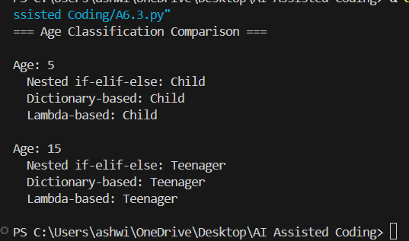

Justification:

This section of the code provides a comparison of different methods for classifying age groups.
It includes three different approaches: nested if-elif-else statements, a dictionary-based method,
and a lambda function-based method. Each method takes an integer age as input and returns a string representing the age classification (Child, Teenager, Adult, Senior, or Invalid age).

Task 4: For and While Loops (Sum of First n Numbers)
Scenario
You need to calculate the sum of the first n natural numbers.
Task
• Use AI assistance to generate a sum_to_n() function using a for loop.
• Analyze the generated code.
• Ask the AI to suggest an alternative implementation using a while loop or a mathematical
formula.
Expected Output #4
• Python function to compute the sum of first n numbers.
• Correct output for sample inputs.
• Explanation and comparison of different approaches.

Prompt:
#2216Write a code to generate a sum_to_n() to find sum of first n numbers using for loop and another approach and give explanation ,comparison of different approaches

Code:

def sum_to_n_for(n):
"""Using for loop: iterate from 1 to n and add each to total."""
total = 0
for i in range(1, n + 1):
total += i
return total
def sum_to_n_while(n):
"""Using while loop: keep adding until counter exceeds n."""
total = 0
i = 1
while i <= n:
total += i
i += 1
return total
def sum_to_n_formula(n):
"""Using mathematical formula: 1 + 2 + ... + n = n * (n + 1) / 2."""
return n * (n + 1) // 2
# ========== Demo ==========
if __name__ == "__main__":
n = int(input("Enter n (positive integer): "))
if n < 0:
print("Please enter a non-negative integer.")
else:
print(f"\nSum of first {n} numbers:")
print(f" for loop: {sum_to_n_for(n)}")
print(f" while loop: {sum_to_n_while(n)}")
print(f" formula: {sum_to_n_formula(n)}")
# ========== EXPLANATION ==========
print("\n" + "=" * 70)
print("EXPLANATION")
print("=" * 70)
print()
# ========== COMPARISON TABLE ==========
print("=" * 70)
print("COMPARISON TABLE")
print("=" * 70)
print(f"{'Aspect':<22} {'for loop':<18} {'while loop':<18} {'formula':<18}")
print("-" * 70)
print(f"{'Time complexity':<22} {'O(n)':<18} {'O(n)':<18} {'O(1)':<18}")
print(f"{'Space complexity':<22} {'O(1)':<18} {'O(1)':<18} {'O(1)':<18}")
print(f"{'Iterations':<22} {'n':<18} {'n':<18} {'0':<18}")
print(f"{'Best for':<22} {'Step-by-step logic':<18} {'Condition-based':<18} {'Just the sum':<18}")
print("=" * 70)

Output:
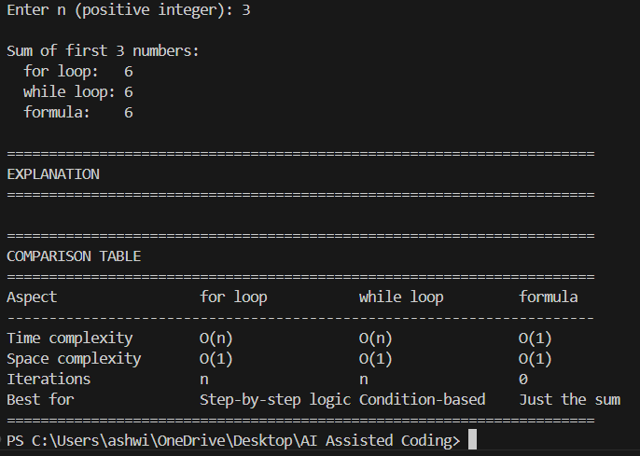

Justification:
1. FOR LOOP
- Uses range(1, n+1) to get 1, 2, 3, ..., n.
- Adds each value to a running total.
- Time: O(n), Space: O(1).
- Good when you need to do something for each number (e.g. print, check).

2. WHILE LOOP
- Same idea as for loop: counter from 1 to n, add to total.
- You manage the counter and condition yourself.
- Time: O(n), Space: O(1).
- Good when the stopping condition is not a simple count (e.g. until sum > 100).

3. FORMULA (n * (n+1) / 2)
- Math identity: 1 + 2 + ... + n = n(n+1)/2.
- No loop; one expression.
- Time: O(1), Space: O(1).
- Best when you only need the sum of 1..n; fastest and clearest.

Task 5: Classes (Bank Account Class)
Scenario
You are designing a basic banking application.
Task
• Use AI tools to generate a Bank Account class with methods such as deposit(), withdraw(),
and check_balance().
• Analyze the AI-generated class structure and logic.
• Add meaningful comments and explain the working of the code.
Expected Output #5
• Complete Python Bank Account class.
• Demonstration of deposit and withdrawal operations with updated balance.
• Well-commented code with a clear explanation

Prompt:
# 2216write a code with class methods as deposit(),withdraw(), and check_balance() add meaningful comments and explain working of code

Code:
class BankAccount:
def __init__(self, owner_name, initial_balance=0.0):
"""
Initialize a new bank account.
:param owner_name: Name of the account holder
:param initial_balance: Starting balance (default 0.0)
"""
self.owner_name = owner_name
self.balance = initial_balance # Store balance as instance attribute
def deposit(self, amount):
"""
Add money to the account.
:param amount: Positive amount to deposit
:return: Updated balance after deposit, or None if amount is invalid
"""
if amount <= 0:
print("Deposit failed: Amount must be positive.")
return None
self.balance += amount
print(f"Deposited ₹{amount:.2f}. New balance: ₹{self.balance:.2f}")
return self.balance
def withdraw(self, amount):
"""
Remove money from the account if sufficient balance exists.
:param amount: Positive amount to withdraw
:return: Updated balance after withdrawal, or None if withdrawal failed
"""
if amount <= 0:
print("Withdrawal failed: Amount must be positive.")
return None
if amount > self.balance:
print(f"Withdrawal failed: Insufficient balance. Current balance: ₹{self.balance:.2f}")
return None
self.balance -= amount
print(f"Withdrew ₹{amount:.2f}. New balance: ₹{self.balance:.2f}")
return self.balance
def check_balance(self):
"""
Return and display the current account balance.
:return: Current balance
"""
print(f"Balance for {self.owner_name}: ₹{self.balance:.2f}")
return self.balance
# ========== Example usage and explanation ==========
if __name__ == "__main__":
# Create an account for "Alex" with initial balance ₹1000
account = BankAccount("Alex", initial_balance=1000.0)
print("--- Bank Account Demo ---\n")
# Check initial balance
account.check_balance()
# Deposit ₹500
account.deposit(500.0)
# Withdraw ₹200
account.withdraw(200.0)
# Try invalid operations (negative amount, excess withdrawal)
account.deposit(-100)
account.withdraw(2000.0)
# Final balance
account.check_balance()

Output:

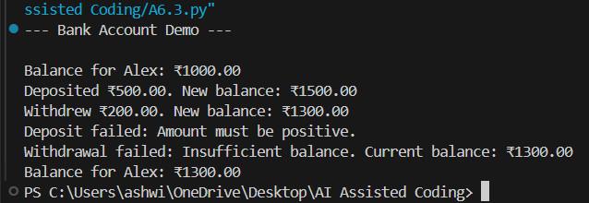

Justification:

1. CLASS BankAccount
- A class is a blueprint. Each account is an object (instance) of this class.
- __init__ runs when you create an account. It stores owner_name and balance
as instance attributes (self.owner_name, self.balance) so every account
has its own name and balance.

2. deposit(amount)
- Checks that amount > 0. If not, prints error and returns None.
- Otherwise adds amount to self.balance and prints the new balance.
- Returns the updated balance so the caller can use it if needed.

3. withdraw(amount)
- Checks amount > 0. If not, prints error and returns None.
- Checks amount <= self.balance. If not, prints "Insufficient balance" and returns None.
- Otherwise subtracts amount from self.balance, prints new balance, and returns it.

4. check_balance()
- Does not change balance. Prints and returns the current self.balance.

5. ENCAPSULATION
- Balance is stored inside the object (self.balance). External code changes
it only through deposit() and withdraw(), so invalid operations (negative
amounts, over-withdrawal) can be rejected in one place.

